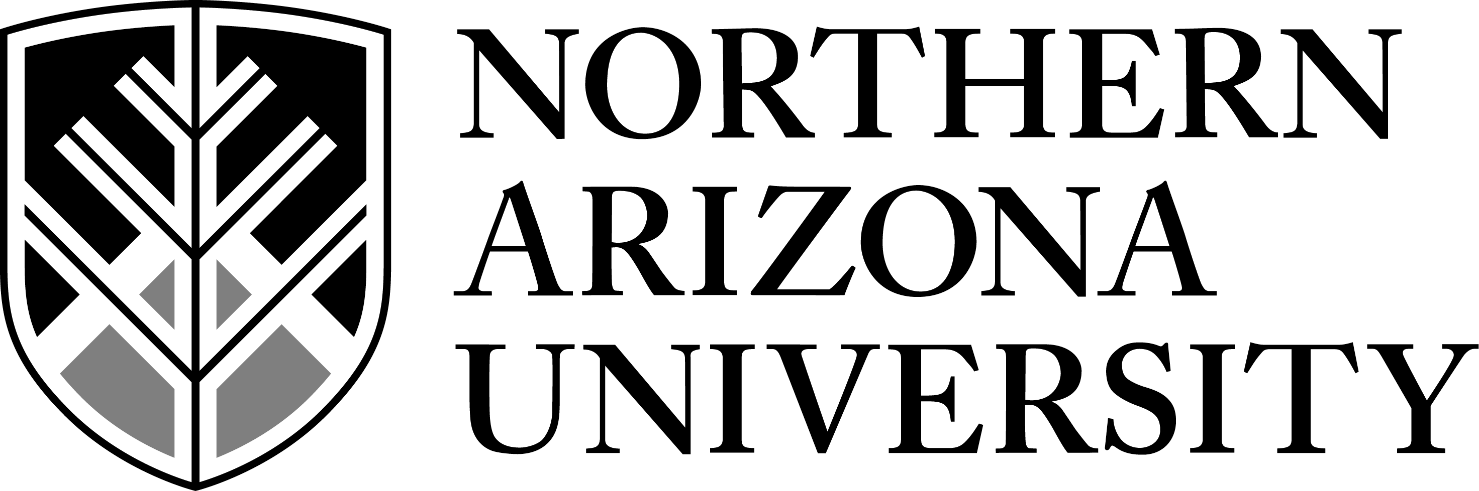
Global Learning Initiative
________________________________________________________________

Implementing NAU’s Global Learning Outcomes

Invitation for Proposals

Spring 2011 or Fall 2011

Description
Academic units are invited to participate in a facilitated review and revision of one or more degree-program curricula to implement NAU’s Global Learning Outcomes beginning in either Spring 2011 or Fall 2011. The Global Learning Initiative, with the support of the Center for International Education and the Office of the Associate Vice President for Diversity, provides structured processes in support of the revision process, including workshops, consultations, facilitation, research, and curriculum and network mapping. Funds will be awarded to support faculty participating in the process.

Background
NAU has taken a bold step that will demonstrate its leadership in global learning. By implementing innovative global learning outcomes, NAU will be one of the very first universities to infuse every element of its curricula with appropriate education on twenty-first-century issues. This invitation is for those who want to take a leadership role in THE forefront of curricular innovation.

In support of the NAU’s Strategic Plan, the Task Force on Global Education’s Global Learning Subcommittee developed recommendations intended to facilitate inclusion of global learning in the curriculum. Global learning is defined, in part, as embracing environmental sustainability, global engagement, and diversity education; themes that have also been identified as the three thematic student learning outcomes. These recommendations were adopted by the NAU Faculty Senate in January 2010 (http://globallearning.nau.edu/files/global_learning_legislation.pdf). The Faculty Senate’s adoption identified the academic majors, the Liberal Studies Program, and co-curricular programming as the three sites for the infusion of the global learning perspectives.

Goals for Participants
The ultimate outcome of this project is to thoroughly and thoughtfully embed the three University Global Learning Outcomes of Diversity Education, Environmental Sustainability, and Global Engagement into a degree program’s curriculum and also utilizes co-curricular learning opportunities and their student’s Liberal Studies Program requirements. See the Appendix for definitions of the three Global Learning Outcomes.

Faculty are encouraged to begin discussions with colleagues and their unit chair/director. The timeline for the project will be determined by the department program’s leaders (key department faculty and chair/director). This round of applicants will be expected to submit completed products for curricular change in accordance with the University Curriculum Committee’s schedule for their college during Fall 2011 and early Spring 2012, if desired changes are to be implemented for the 2012-13 academic year catalog.

The three core tasks associated with this project are as follows;
- The identification and/or development of student learning outcomes that align with all three of the University’s Thematic Global Learning Outcomes and utilize language to articulate knowledge, skills, and dispositions/perspectives that are both substantive and articulated in terms meaningful to the discipline.
- The development of a comprehensive set of learning strategies grounded in the major, the co-curriculum, and the Liberal Studies Program that provides opportunities for students to realize the Global learning Outcomes as described in the first goal.
- The development and implementation of assessment strategies as part of the department’s Assessment Reporting and Planning cycle to ensure that continued data-driven evidence addressing the degree program’s global learning outcomes is collected and considered as a component of the degree program’s decision-making processes.

Process
Participation will engage a program’s faculty in a facilitated process of defining program global learning outcomes, formation and analysis of their program’s global learning curriculum and networking maps, revision of course syllabi, and the development of products that will flow directly into the curricular and assessment change processes.

Each degree program will:
- Identify a faculty member to serve as the internal facilitator (or co-facilitators) for the project who will be responsible for convening the program’s faculty for crucial discussions, delegating and facilitating faculty work over the course of the project, and overseeing development of formal curricular proposals emerging from the redesign.
- Identify one additional faculty member to join the internal facilitator as the department’s lead team (for academic units of 10 or fewer faculty), or two additional faculty members to join the internal facilitator as the department’s lead team (for larger academic units) to assist with the project in the department. At least one team member (either internal facilitator or lead team member) must be a senior, tenured faculty member of influence in the department.
- Insure that all full-time tenured or tenure-track faculty teaching within the program take part in crucial discussions and decisions, as determined by the specific goals of each department participating in the process.
- The department/school chair or director is expected to support the project with consultation, guidance, and administrative support that is reasonable.

The Global Learning Initiative will provide:
- Support for academic units to develop student learning outcomes for the program based upon the University Thematic Global Learning Outcomes.
- Support for academic units to develop department/major-specific competencies in global learning for a prospective graduate of their program.
- Support for academic units to develop an assessment program that provides a clear evaluation of whether a prospective graduate has mastered the targeted department/major-specific competencies.
- Support for academic units to construct an effective and integrated curriculum that links together an appropriate mix of department courses, Liberal Studies courses, other department courses, co-curricular activities, service learning, and other structured and unstructured learning experiences to develop the global learning competencies required by the program for graduation.
- Support for academic units to map each element of the curriculum to the learning outcomes it supports and develop a sequence of learning experiences from year one through year four.
- Support for academic units to structure the program and course curriculum changes, as well as the assessment program so that they fit seamlessly into various established university processes and procedures for curriculum change approvals, program assessment, faculty performance evaluation, and accreditation.

Financial support
Funding will be awarded to assist with the project. Facilitation and other support will be provided through by the Global Learning Initiative (see Appendix for more information) in collaboration with the Center for International Education.

Each internal facilitator (or co-facilitators) and all members of the department’s lead faculty team will each receive either a stipend of $4,000 as a compensated overload salary, or a course release (pending the availability of salary-replacement faculty) to participate in this work. Stipends will paid as the department achieves key benchmarks in the process. Details of the process will be discussed in the Planning Meeting, below.

Statement of Interest
Academic leaders in the unit (including the prospective internal facilitator(s), lead faculty team members, and chair/director) are invited to submit a brief statement of interest not to exceed two pages.

The statement should include the following information:
- Names and contact information of the internal facilitator(s), lead faculty team members, and chair/director for the academic unit and identification of the program(s) to be redesigned
- Degree program’s goals for the curricular redesign
- Expected timeline
- Request for stipends or course buy-outs
- Endorsement by the department chair and the college dean should accompany the statement

Planning Meeting
As part of the application process, a planning meeting will be scheduled with your internal facilitator(s), department team members, department/school leadership, and the leadership of the Global Learning Initiative. The purpose of this meeting will be to introduce key personnel and clarify key expectations, goals, commitments, and timelines.

Proposals will be reviewed on an ongoing basis beginning on October 29, 2010.
All proposals are due by November 5, 2010. Decisions will be made very shortly thereafter.

Please submit proposals electronically to Angela Roberson (angela.roberson@nau.edu) of the Center for International Education on behalf of the Global Learning Initiative.

APPENDIX

How are the University Global Learning Outcomes defined?

At NAU, global competence is achieved through intentional curricular and co-curricular experiences that foreground global learning. The curriculum will provide students with opportunities to learn how their identity is shaped by their community, their society, and the world. They will also have opportunities to expand their abilities to interact effectively across cultural barriers, and communicate in language(s) other than English. These goals will be achieved through the following three University Thematic Student Learning Outcomes:

- Global Engagement: Students will learn how to analyze, synthesize, and evaluate the interconnectedness and interdependence of the human experience on a global scale.
- Environmental Sustainability: Students will acquire the skills and knowledge base to understand the importance of and options for environmental sustainability in local and global terms. Students will also acquire an understanding of the range of ethical perspectives concerning the uses of natural resources and the impact of these perspectives on creating a sustainable relationship to the natural environment.
- Diversity Education: Students will learn about and critically reflect upon the nature and consequences of diversity in both the social (e.g. ethnic, religious, cultural) world and the natural environment, and develop an understanding of how this diversity both alters and is altered in a world characterized by increasing global interaction.

Please see the complete set of Global Learning Recommendations as adopted by the NAU Faculty Senate in January 2010 for additional background and contextual discussion at http://globallearning.nau.edu/files/global_learning_legislation.pdf

The Global Learning Initiative is represented by members of the Global Learning Committee:

Blase Scarnati (Chair), Cynthia Anderson, Bill Auberle, David Camacho, Harvey Charles, Chuck Connell, Ron Hubert, David Schlosberg, Abe Springer, Miguel Vasquez, and Maribeth Watwood.

